EXPERIMENT-3
Name: Padma Priya D Roll No: 240701377
1.COMMAND LINE INTERFACE:
PYTHON CODE:
filename = input("Enter file name to create: ")

try:
with open(filename, "w") as f:
f.write("This file is created using CLI.")
print("File created successfully!")
except:
print("Error creating file")

OUTPUT:
2.GRAPHICAL USER INTERFACE:
PYTHON CODE:
import tkinter as tk
from tkinter import messagebox

def create_file():
filename = entry.get()
if filename == "":
messagebox.showwarning("Warning", "Enter file name")
return

with open(filename, "w") as f:
f.write("This file is created using GUI.")

messagebox.showinfo("Success", "File created successfully!")

root = tk.Tk()
root.title("Create File - GUI")
root.geometry("300x150")

tk.Label(root, text="Enter file name:").pack(pady=5)
entry = tk.Entry(root)
entry.pack(pady=5)

tk.Button(root, text="Create File", command=create_file).pack(pady=10)

root.mainloop()

OUTPUT:
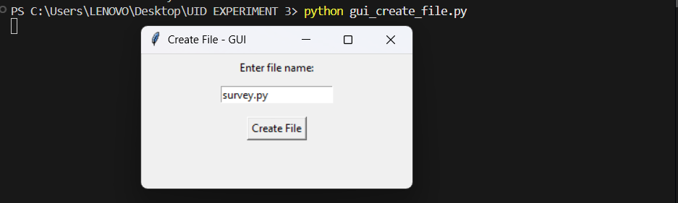
3.VOICE USER INTERFACE:
PYTHON CODE:
import speech_recognition as sr

r = sr.Recognizer()

with sr.Microphone() as source:
print("🎤 Say the file name to create")
audio = r.listen(source)

try:
filename = r.recognize_google(audio)
filename = filename.replace(" ", "") + ".txt"

with open(filename, "w") as f:
f.write("This file is created using Voice Interface.")

print("File created:", filename)
print("✅ File created successfully!")

except:
print("❌ Could not understand voice")

OUTPUT:

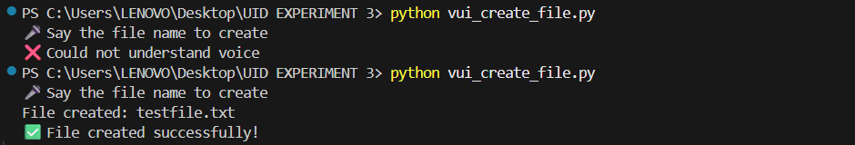

4.USER SATISFACTION COMPARISON:

PYTHON CODE:

print("User Satisfaction Survey (1 to 5)")

cli = int(input("Rate CLI file creation: "))
gui = int(input("Rate GUI file creation: "))
vui = int(input("Rate VUI file creation: "))

avg = (cli + gui + vui) / 3

print("\nResults")
print("CLI:", cli)
print("GUI:", gui)
print("VUI:", vui)
print("Average Satisfaction:", avg)

OUTPUT:

